**DAILY ONLINE ACTIVITIES SUMMARY**

|  |  |  |  |  |  |  |  |  |
| --- | --- | --- | --- | --- | --- | --- | --- | --- |
| **Date:** | **22-05-2020** | | | | | **Name:** | **Latika Kavoor** | |
| **Sem & Sec** | **4th Sem & A-Section** | | | | | **USN:** | **4AL18CS035** | |
| **Online Test Summary** | | | | | | | | |
| **Subject** | | **OS** | | | | | | |
| **Max. Marks** | | **30** | | **Score** | | | **23** | |
| **Certification Course Summary** | | | | | | | | |
| **Course** | **Introduction to Cyber Security** | | | | | | | |
| **Certificate Provider** | | | **ICT Academy - CISCO** | | **Duration** | | | **30 hrs** |
| **Coding Challenges** | | | | | | | | |
| **Problem Statement:**1. Hint: First Create a Singly Linked List Stack with the node corresponding to First Element is the base of the stack; and its link field must be always Null. When you push First Element, It is the First and it is Base of the stack. Its Link must be Null. top pointer pointing to First. (top = First) When you push any element, (No need of checking Stack full case because SLL is dynamic) Create a new node called temp using malloc function and insert the a number into Data field, and Link field must be pointing to top; and move the pointer top to point to temp. When you pop, First check for stack Empty. if First == NULL, then Stack Empty. If it is not empty, The pointer temp must be pointing to top. Move the pointer top to top->link. delete temp. When you display the stack element, First Check for Stack Empty as in pop operation. If it is not empty, Display all the elements of current stack starting from top to First. | | | | | | | | |
| **Status:Completed** | | | | | | | | |
| **Uploaded the report in Github** | | | | | **Yes** | | | |
| **If yes Repository name** | | | | | <https://github.com/Latika31/lockdown-coding> | | | |
| **Uploaded the report in slack** | | | | | **Yes** | | | |

Online Test Details: (Attach the snapshot and briefly write the report for the same)

Took the online test from 9:15 to 9:55

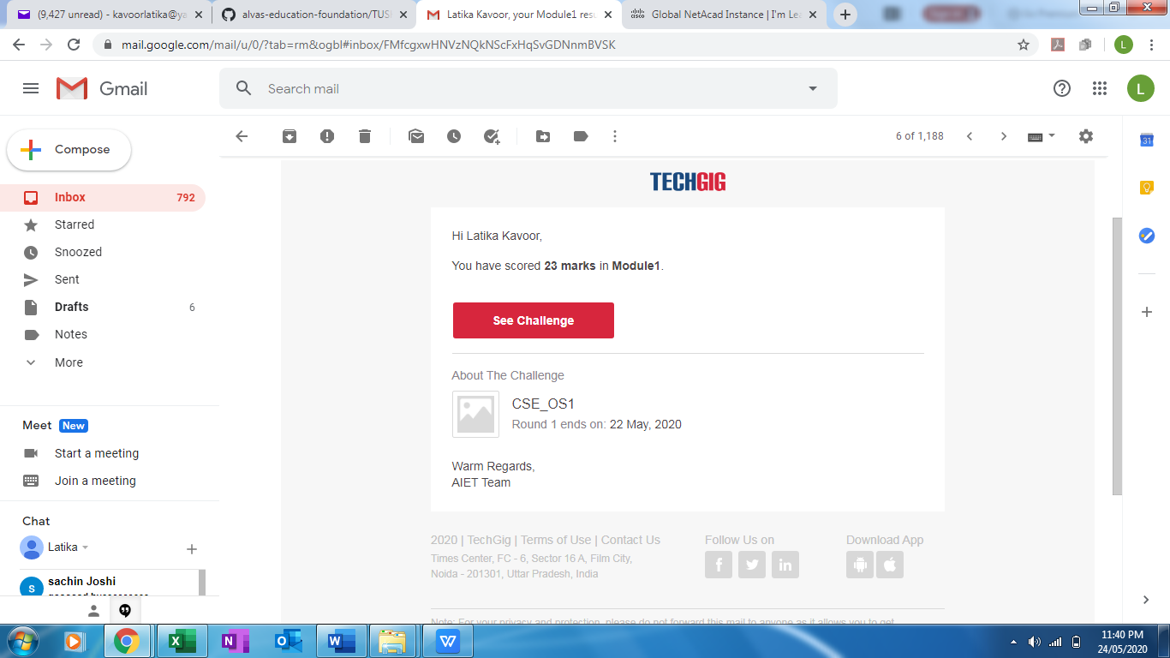

Certification Course Details: (Attach the snapshot and briefly write the report for the same)

Learnt few more topics of Introduction on Cybersecurity



Coding Challenges Details: (Attach the snapshot and briefly write the report for the same)

Solved problems and uploaded the same on github

